-

**Contact Us**

**Kowloon Tong Campus: 2707 4669**

**Telford Annex: 2707 9440**

**E-mail:** [**uowchk-ss@uow.edu.au**](mailto:uowchk-ss@uow.edu.au)

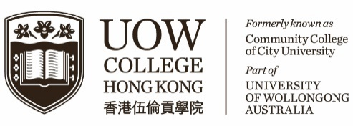**S T U D E N T**

The Student Centre C1459

Dear students,

**The Student Centre – Career Development**

**Summer Internship Programme 2022**

The Student Centre is pleased to announce that the **Summer Internship Programme 2022** are now open for application!

Working as an intern provides you the chance to gain first-hand industry knowledge from an organization and its professional people. This enables you to determine if you have an interest in a particular career and to practice networking skills while establishing a network of professional contacts and references. You will also learn new skills and add to your knowledge base while gaining confidence in your abilities. Simply click [HERE](https://www.uowchk.edu.hk/current-students/student-services/the-student-centre/career-development/) to browse a variety of internships that are currently available.

|  |  |  |
| --- | --- | --- |
| **Code** | **Summer Internship Programme** | **Application Deadline** |
| C1465 | [Tai Hing Worldwide Development Limited](https://www.uowchk.edu.hk/site-assets/uow-college-hong-kong/bcm/C1465_Tai-Hing-advertisment.docx) | 15 June 2022 |
| C1496 | [JK Universal Limited](https://www.uowchk.edu.hk/site-assets/uow-college-hong-kong/bcm/C1495_JK-Universal-Limited.docx) | 20 June 2022 |
| C1497 | [Horus Limited](https://www.uowchk.edu.hk/site-assets/uow-college-hong-kong/bcm/C1496_Horus-Limited.docx) | 20 June 2022 |
| C1498 | [Candela](https://www.uowchk.edu.hk/site-assets/uow-college-hong-kong/bcm/C1498_Candela-Medical.docx) | 15 June 2022 |

Students interested in the placement opportunities should read their respective requirements and job responsibilities and follow the application procedure to submit their applications. Applicants are reminded that they should submit their applications using their **UOW email addresses** otherwise will not be entertained. Job titles must be indicated in the subject line of their email.

Any ineligible, late or incomplete applications will not be considered and applicants will NOT be informed of unsuccessful applications. If you have any queries or concerns regarding the summer internship programme, you are welcome to contact The Student Centre via email ([uowchk-ss@uow.edu.au](mailto:uowchk-ss@uow.edu.au)).

The Student Centre

UOW College Hong Kong

Counselling Services &

Personal Development

**CE N T R E**